CCT
CCT (Carrier Configuration Tool) consists of the following components:
- 1 – 4 CCAs (Carrier Communication Arrays)
- 1 CCT cabinet
- 24VDC power cables
- RS422 cables
The CCAs are placed in the left side of the sorter frame (as seen in the direction of flow), while the CCT cabinet is placed across the sorter frame as shown in Fig. 1-1.
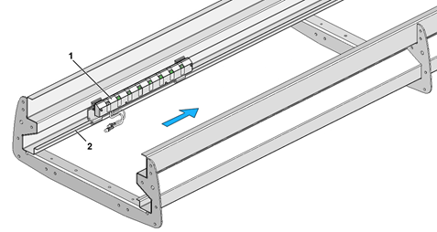
Fig. 1-1 CCT mounted in section
1. | CCA
2. | Mounting flange on cable tray of section

Preparation necessary
Installation of the following parts of the sorter must be complete before the CCT components are installed:
- Supports
- Sections

 | Note!  The CCAs must always be installed on the left-hand side of the sorter frame as seen in the direction of flow.

Tools
Supplied Customer Tool Kit TT/CB 4000

Guides
- Electrical component location drawing
- Cable lists
- Circuit diagram for CCT

Mounting af CCA
.1 The CCAs are placed in the left side of the sorter frame according to the drawing showing the position of components.
.2 Position a CCA on the section’s mounting flange as shown in Fig. 1-2 with the top part of the holders touching the section’s vertical running surface.
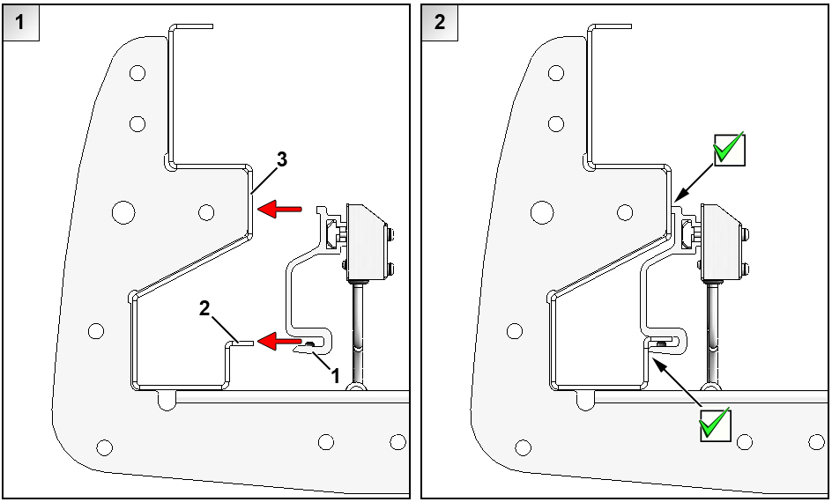
Fig. 1-2 Position of CCA
1. | Holder for CCA
2. | Mounting flange
3. | Vertical running surface on section

.3 Check that the CCA is in the desired position as specified in the drawing showing the position of components.
.4 Tighten the securing screws as shown in Fig. 1-3.
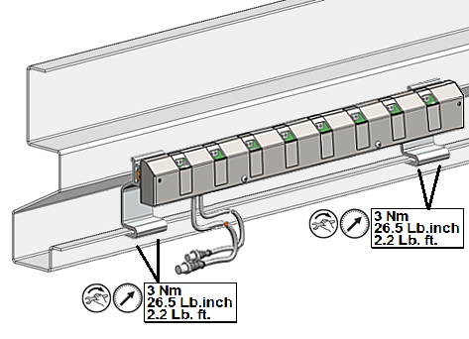
Fig. 1-3 Mounting of CCA

.5 Mount the other CCAs according to the drawing showing the position of components.

Note!
The running time of the carts between two CCAs must be at least 5 seconds. The distance between two successive CCAs is calculated as a function of the running time and the speed of the sorter.
Example:
At a sorter speed of 2.1 m/s the minimum distance between two CCAs is calculated as: L_{CCA} = 2.1m/s * 5s = 10.5m.

Note:
Each CCA contains a printed circuit board with 4 DIP-switches, that are adjusted ex factory. The correct DIP-switch setting is shown in the circuit diagram for CCT.

Mounting of CCT cabinet
.6 The CCT cabinet is mounted according to the following guide:
- Installation guide for cabinets for I/O modules

Mounting of cables
The following Fig. 1-4 shows an example of the cabling between the CCT cabinet and four CCAs. The CCT cabinet with the port server can be placed differently and the number of CCAs can vary. The project specific cabling is to be done according to the cable list.
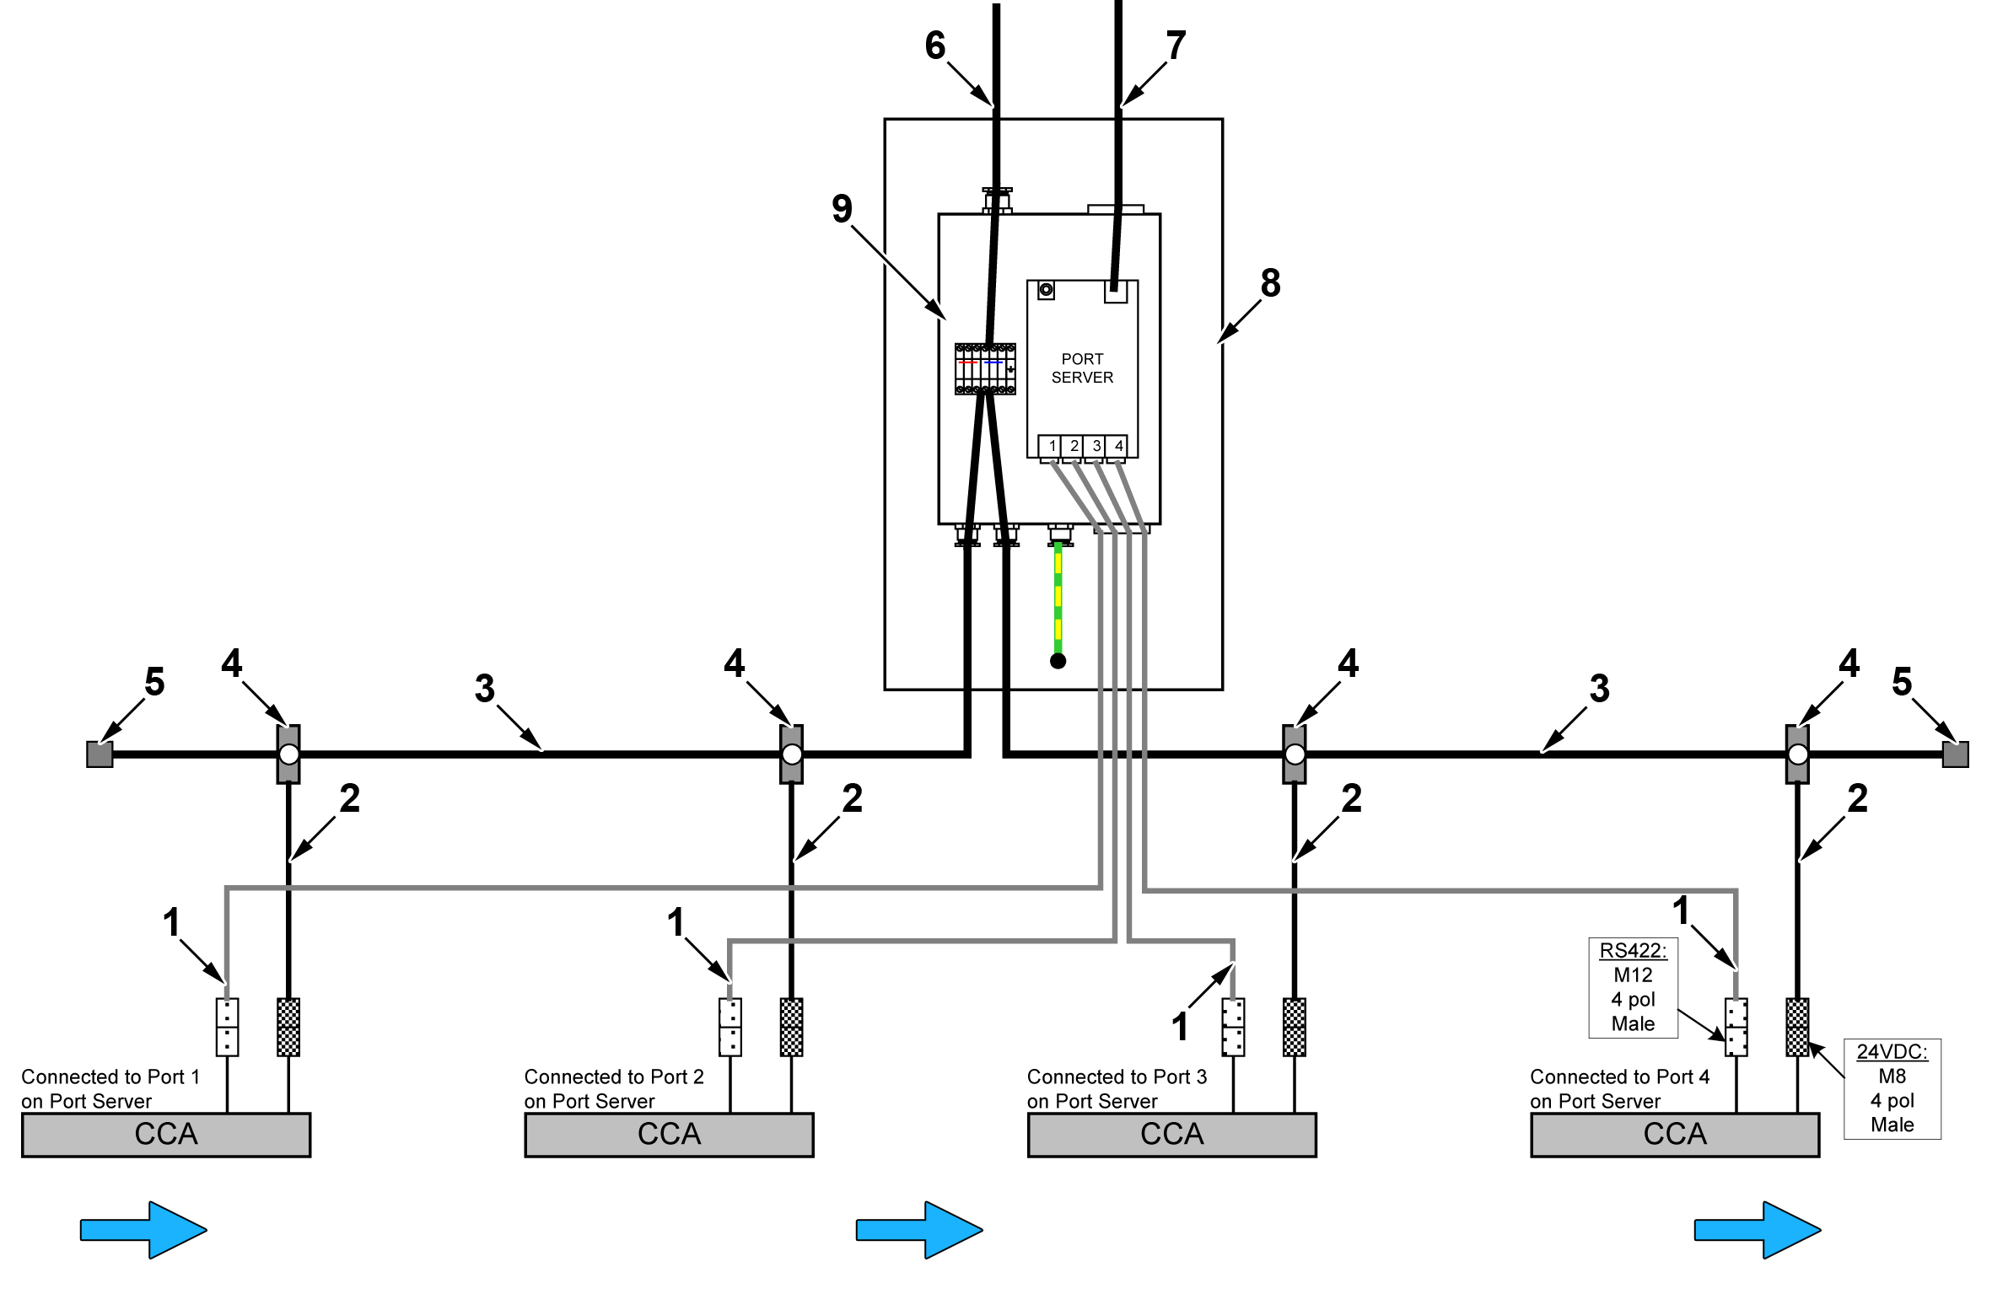
Fig. 1-4 Cable overview for CCT cables
1. | RS422 cable (478B935.L) | 6. | 24VDC power cable
2. | 24VDC power cable (474B662.L) | 7. | Ethernet cable
3. | AS-i bus cable | 8. | CCT cabinet
4. | AS-i branching with M12 connector (174A085) | 9. | Box with port server
5. | AS-i screw cap

RS422 communication
.1 Connect the RS422 cable to the M12 connector of the CCA (Fig. 1-5 /1).
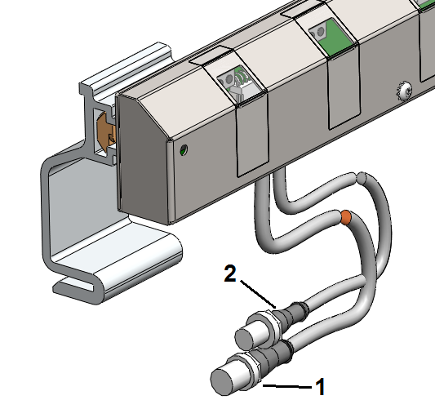
Fig. 1-5 Electrical connections for CCA
1. | RS422 connector, M12, 4-pole, male | 2. | 24VDC connector, M8, 4-pole, male

.2 Lead the RS422 cables to the CCT cabinet in the left cable tray of the sorter section.
.3 Lead the RS422 cables in to box with port server through cable entry as shown in Fig. 1-6
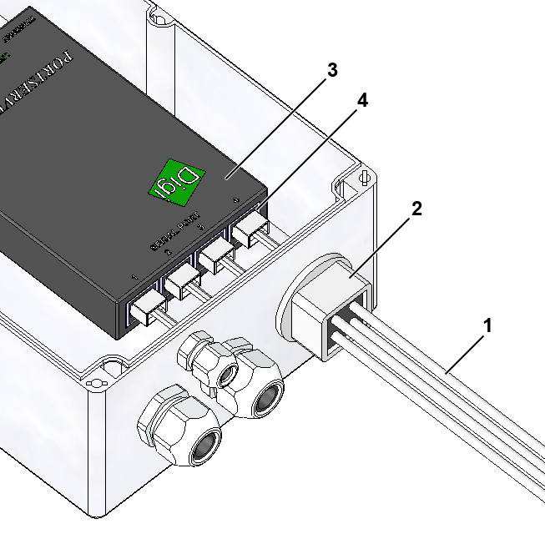
Fig. 1-6 Connection of RS422 cable in port server
1. | RS422 cable | 3. | Port server
2. | Cable entry, 4 x 3mm | 4. | Serial ports

.4 Connect the RS422 cables in the serial ports of the port server:
- The first CCA (as seen in the direction of flow) is connected to port 1 on the port server.
- The second CCA is connected to port 2 on the port server.
- The third CCA is connected to port 3 on the port server.
- The fourth CCA is connected to port 4 on the port server.

24VDC power cable
.1 Connect the 24VDC cable to the M8 connector of the CCA (Fig. 1-5 /2).
.2 Lead the 24VDC cables to the CCT cabinet in the left cable tray of the sorter section.
.3 Connect the 24VDC supply cables according to the cable list.

